

**Exploratory Data Analysis (EDA)**

For COVID19 Daily Report

Presented by:

Nasser Alshehri

21 November, 2021

# Introduction

The virus that causes COVID-19 is known as SARS-CoV-2 It appears to have first emerged in Wuhan, China, in late 2019,

The outbreak has since spread across China to other countries around the world. By the end of January, the new coronavirus had been declared a public health emergency of international concern by the WHO,

The most commonly reported symptoms include a fever, dry cough and tiredness, and in mild cases people may get just a runny nose or a sore throat,

In the most severe cases, people with the virus can develop difficulty breathing, and may ultimately experience organ failure. Some cases are fatal.

# Study [Methodolog](https://github.dihe.moe/sanjeevai/nyc_subway_data_analysis#p2)y

The methodology of this project is as follows, extracting data from Kaggle which is COVID19 Daily Report and it was more than 14316 Rows and 9 Columns ,

In the cleaning step, we dropped the missing values in the dataset and the anomalous values ,

We explored the data and applied comprehensive analysis methods to the data and extracted important information from the data, for example, continent has the most confirmed cases of coronavirus Europe ,continent has the lowest number of deaths from the Corona virus is Africa .

# Data Description

The data set is provided in .csv format, contains information of confirmed, country, date, death, latitude, longitude, recovered, continent.The data set was extracted from Kaggle .

|  |  |
| --- | --- |
| **Variables** | **Description** |
| **confirmed** | Number of Confirmed Cases |
| **country** | country |
| **date** | Date |
| **death** | Number of Deaths |
| **latitude** | latitude |
| **longitude** | longitude |
| **recovered** | Number of Recovered cases |
| **continent** | Continent of the country |
| **active** | Number of Active cases |

# Tools and Libraries:

* Python.
* Jupyter Notebook.
* PowerPoint.
* Excel
* NumPy.
* Pandas.
* Matplotlib

# Data analysis

After we prepared the data, Then we used some of visualisation tools such matplotlib to look what is the most common increase and decrease in Corona cases in all continents around the world and recovered , and Deaths , Actives , as of January 2020 until July 2020 .

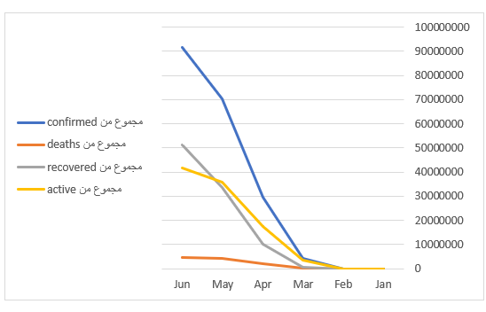

This graph shown the continent has the most confirmed cases of coronavirus Europe and The least confirmed cases of coronavirus North America , Africa

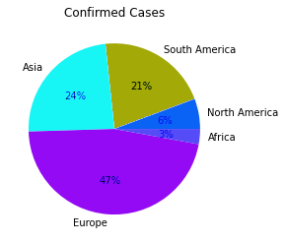

This bar graphs shows continent has the lowest number of deaths from the Corona virus is Africa , continent with the most deaths from the Corona virus is Europe.

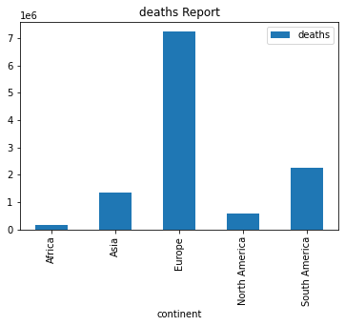

This graph shown the many people have recovered from the Corona virus around the world from 1/1/2020 to 29/6/2020

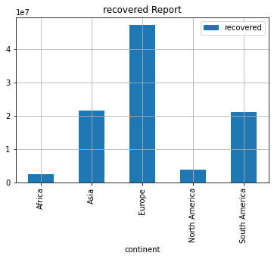

# Conclusion

* know the increase and decrease in Corona cases in all continents around the world and Deaths , Actives , recovered as of January 2020 until July 2020 .
* And Knowing in each country what are the decision about Quarantine , also, pharmaceutical manufacturers benefit to be exported to each country according to the infected cases .

# Reference

Source : https://www.kaggle.com/jebathuraiibarnabas/-covid19-daily-report